Week-4(4-4-2022)

1. Design Check board using HTML and CSE.

2. Design Tic Tac Toe Game using HTML and CSE.

3. Create below html page using frames. Refer page number 78

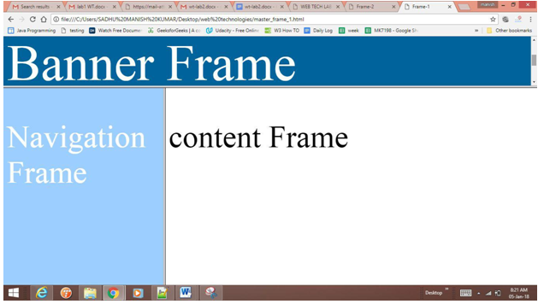

4 . Design a student Educational portal using HTML and CSE.

References: <https://utemplates.net/education-html-website-templates/>

<https://www.template.net/web-templates/website-templates/student-template/>

<https://colorlib.com/wp/school-website-templates/>